# Картинки по запросу эмблема министерства спорта и туризма

**Tourism in Belarus**



**Geographically our country is situated in the heart of Europe. Our closest neighbours are Lithuania, Latvia, Ukraine, Poland and the Russian Federation.**

**Due to its geographic location, Belarus has well-developed air, road and railway links with many countries.**

**Minsk is a safe and dynamically developing city, where modern buildings blend harmoniously with the buildings of the middle of the last century.**

**Belarus possesses everything necessary for the development of business tourism: the favorable location in the center of Europe, safety, growing economy, high standards of hotel and restaurant service.**

**Being a European city, Minsk cannot do without a well-developed entertainment infrastructure. It offers a wide range of casinos, bars and restaurants, night clubs.**

**There is a unique place in Belarus – the Berezinsky biosphere reserve. It’s the only place in Europe where “the European big five” of large mammals – elk (moose), bison, bear, wolf and lynx live on one compact territory in the wild inhabits.**

**The definite advantage of our resorts over similar facilities in other countries is a good ratio of price and quality, modern medical base and highly skilled specialists. In addition to the wellness services they offer dental services, beauty and SPA treatments.**

**On the basis of Belarusian health resorts speleological clinics are created. They are represented by the complexes, which are composed of white and red salt blocks of the potash mines. The city of Soligorsk has a unique speleological underground clinics (at a depth of 420 m). The Republican Clinics of speleotherapy in Soligorsk is included in the list of leading clinics of Europe, where patients get high quality treatment in the healing salt caves.**

**Great attention in our country is paid to development of active tourism. Many hiking and cycling routes through the most beautiful places of our country are created, exciting kayaking trips and rafts on ponds, horseback riding tours, etc. are created.**

**Visit for more information: www.belarus.travel**

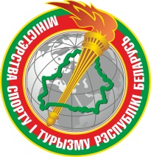 

**Tourist events**

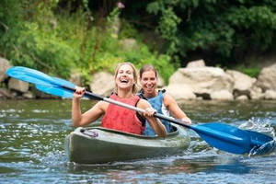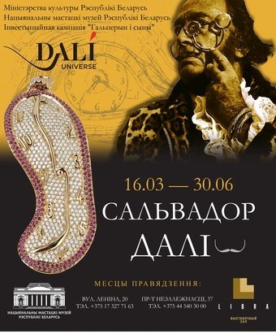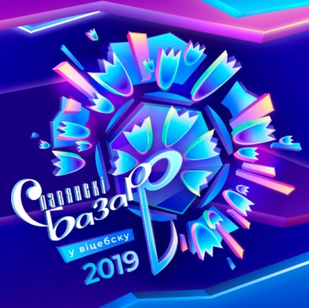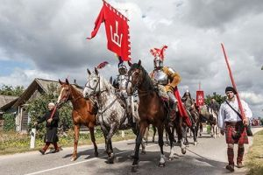

## International Festival of Arts «Slavyanski Bazaar in Vitebsk»

**11 – 15 July, Vitebsk**

From July 9 to July 17, 2019, Vitebsk will host the XXVIII International Art Festival «Slavic Bazaar in Vitebsk» is the largest cultural forum in the Republic of Belarus, bringing together countries and continents.

The main goal of the festival is to strive for the spiritual unity of nations, which emphasizes the motto of the festival «Through art to peace and mutual understanding». The festival «Slavic Bazaar» has long crossed the borders of the Slavic world: representatives of all five continents of the world take part in the international art competition.

## Salvador Dali exhibition in Minsk

**16 march – 30 June, Minsk**

Thanks to founder of the collection and president of the Salvador Dali company Beniamino Levi, who worked with the Spanish surrealist in the 1960s, Minsk residents will see an exposition of more than 100 artworks created by Dali. The collection includes sculpture, graphics, jewelry, decorative and applied art.

**+375-17-342 34 29, www.artmuseum.by**

## Festival of medieval culture «Golshansky Castle»

**18 May**, **Oshmyany district, Golshany, [Golshansky Castle](https://ekskursii.by/?place=16368_Golishanskij_zamok_Sapeg" \o "Read more about Golshansky Castle" \t "_blank)**

At the end of May, 2019 the 10th anniversary festival of medieval culture «Golshansky Castle» will be held in the Oshmyany district. Already traditionally the festival will be held in Golshany under the walls of [of the legendary castle](https://ekskursii.by/?place=16368_Golishanskij_zamok_Sapeg" \t "_blank" \o "Read more about Golshansky Castle) of the Sapiehas. The festival is ready to surprise visitors with knightly and equestrian tournaments, archer competitions, master classes in medieval dances, and demonstration performances by historical reconstruction clubs.

Also city of masters will be organized for the guests of the festival, and children can have fun at the rides. The festival will traditionally end with performances of Belarusian folk groups and grand fireworks.

## Festival of water tourism «Motolskaya regatta-2019»

**1-2 June, urban village Sporovo, Berezovsky district, Brest region**

At the beginning of summer, in June 1 - 2, 2019 , in the urban village Sporovo, Beryozovsky District, Brest Region, the fifth annual Festival «Motolskaya regatta-2019» will take place. For many years this event has become a real holiday of water tourism and an active lifestyle. This year the regatta will start on the Sporovskoye lake. During the festival, lovers of water sports will be able to participate in a sports competition. Athletes can compete in a kayak twos or singles, and the winner will be the crew that showed the best time.

In addition to water competitions, you will find a rich cultural and sports program: futsal, beach volleyball, darts, orienteering, kayaking and cycling.



**UNESCO heritage**

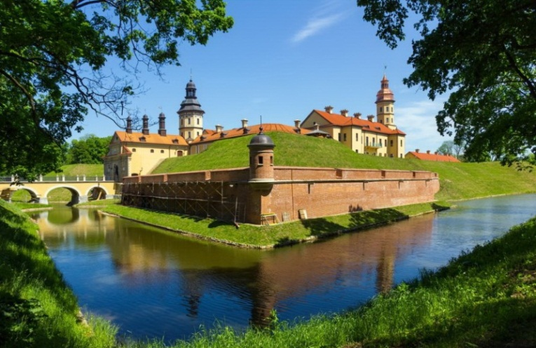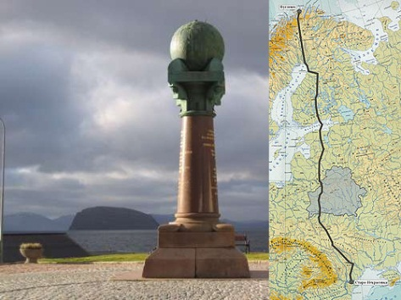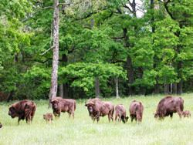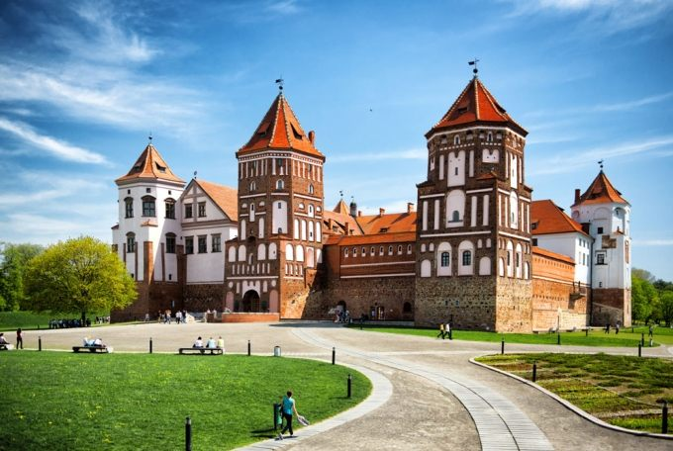

Struve Geodetic Arc

**The Struve**[**Geodetic**](https://en.wikipedia.org/wiki/Geodesy)**Arc is a chain of survey triangulations stretching from**[**Hammerfest**](https://en.wikipedia.org/wiki/Hammerfest)**in Norway to the**[**Black Sea**](https://en.wikipedia.org/wiki/Black_Sea)**, through ten countries and over 2,820 km, which yielded the first accurate measurement of a meridian.**

**19 topographic points of the Struve Geodetic Arc are located in Belarus, 5 of them are included into UNESCO heritage list:**

**"Tupischki" in [Ashmyany](https://en.wikipedia.org/wiki/Ashmyany" \o "Ashmyany) district;**

**"Lopati" in [Zelva](https://en.wikipedia.org/wiki/Zelva" \o "Zelva) district;**

**"Ossownitza" in**[**Ivanovo**](https://en.wikipedia.org/wiki/Ivanovo_(Belarus)) **district;**

**"Tchekutsk" in Ivanovo district**

**"Leskowitschi" in Ivanovo district.**

Belovezhskaya Pushcha

**“Belovezhskaya Pushcha” National Park is rich in various species of plants and animals, many of them enlisted in the Red Book of the Republic of Belarus.**

**Belovezhskaya Pushcha is the last natural habitat of the biggest European mammal species today – zubr (European bison).**

***Kamienyuki; Brest Region.* www.npbp.by**

***+375 1631 56267, +375 1631 56398***

Nesvizh Palace

**Nesvizh Palace is considered the most beautiful palace in Belarus. It was rebuilt many times and as a consequence has features of many architectural styles including renaissance, baroque, rococo, classicism, neo-gothic, modernism.**

**The gardens are a particular attraction, with ornamental lakes, and beautifully landscaped gardens.**

***Leninskaya str. 19; Niasvizh, Minsk Region.* www.niasvizh.by**

***+375 1770 51383***

Mir Castle Complex

**A unique monument of national culture of Belarus. The architectural ensemble of Mir includes a museum castle of the 16-20th centuries with 39 high-grade expositions, embankments, picturesque parks and a pond, a church.**

***Krasnoarmeyskaya street, 2; Mir; Korelichi District, Grodno Region.* www.mirzamak.by**

**+ 375 01596 2 82 70, + 375 01596 2 82 90**



**Sports objects**

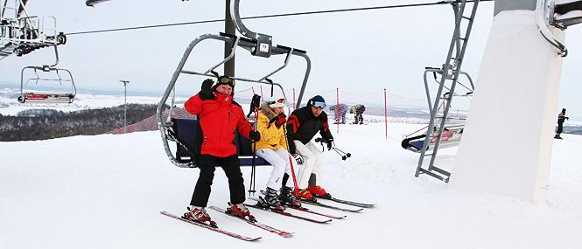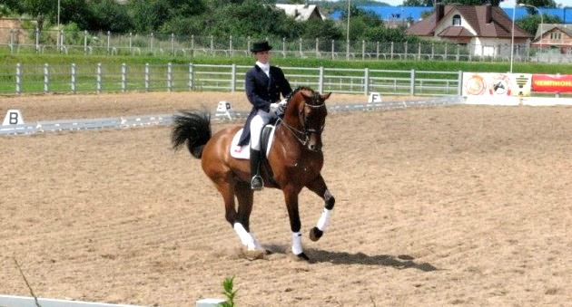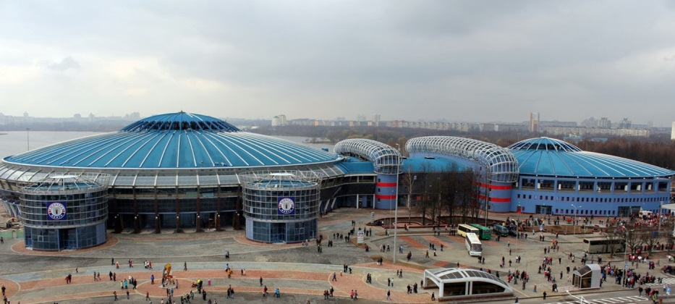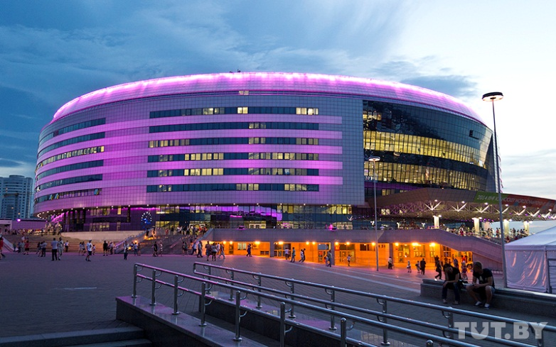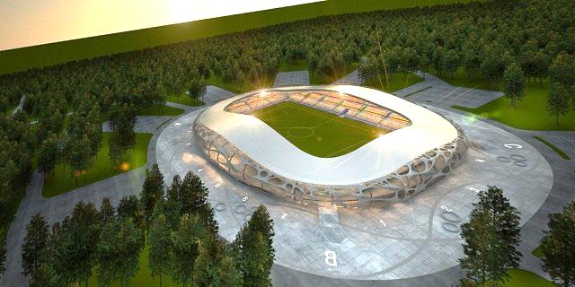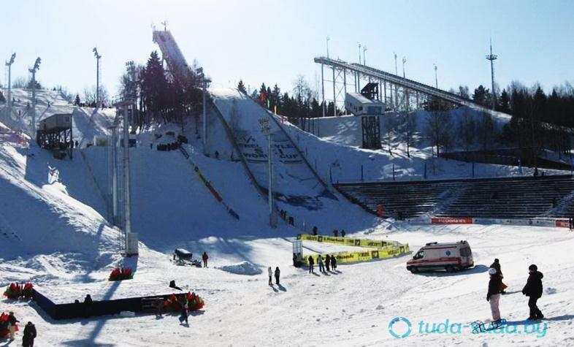

**The Republican centre of Olympic training for winter sports "Raubichi" provides the training of biathletes and skiers, freestylers, skaters, ski jumpers. This complex is marked with UIPMB Golden badge. In 1996, the international biathlon Union awarded the USC "Raubichi" highest "A" category, issuing a license to host top-level competitions without any exceptions.**

**The Republican ski center "Silichi" is the pride of the belarusian industry of tourism and recreation. When selecting a location for the construction the main advantage of the local hilly landscape was considered. The existing natural terrain had 76 metres drop from the top to the bottom. With barrow of 30 metres it turned to differential of up to 100 m slopes, the angle of which allows you to use them for downhill racing.**

**The multifunctional sports and entertainment complex "Minsk-arena" is the largest in Europe a unique sports object. In Europe, only three cities have ice rinks that are larger than the capacity "Minsk-Arena". It has everything you need to practice 30 sports, includes multi-function home arena with room for up to 15 thousand people, a skating track with a Seating capacity of   
3 thousand spectators, a velodrome for 2 thousand seats, tiered Parking and administrative buildings.**

**The Borisov arena is a football stadium in Borisov, the home ground of the football club BATE and the national team of Belarus. Its capacity reaches 13 121 viewers.**

**It is a pure football stadium corresponding to the requirements of the fourth category of UEFA, allowing to host not only matches the qualifying stages of the European Cup, but also the matches of group stage and playoffs of the Champions League and European League.**

**Republican centre of Olympic training of equestrian sport and horse breeding in Ratomka meets all international standards. Center in Ratomka is the only in the CIS, where we organized centralized training of young men and juniors. Thanks to that the youth team of Belarus wins the first places in competitions in the CIS, Baltic States and Eastern Europe.**

**Multifunctional cultural and sports and entertainment complex "Chizhovka-arena" is located in a picturesque recreational area of Chizhovskoye reservoir in the Tashkent street on part of the territory of the park named after 900th anniversary of Minsk and can accommodate about 10,000 spectators.**



**The main international and open sports events to be held in Belarus in 2019**

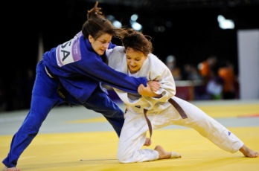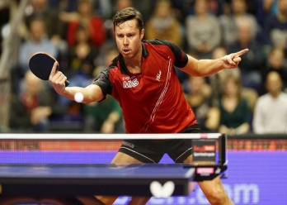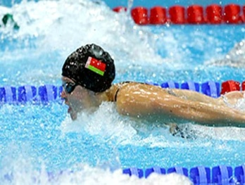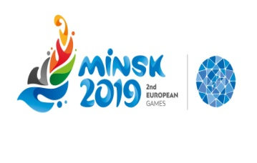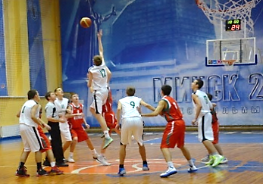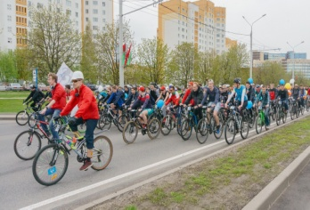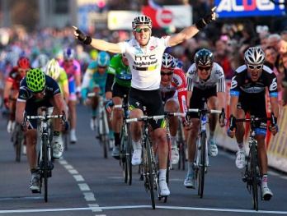

2nd European Games 2019

**Minsk, 21-30 June**

**+375-17-308 72 31, minsk2019.by/ru**

Basketball.

Basketball International Competitions ”Halpskiy’s Cup“ (female)

**Minsk, 2-4 June**

**+375-17-292 86 30,** [**info@bbf.by**](mailto:info@bbf.by)**,** [**www.bbf.by**](http://www.bbf.by)

Cycling.

|  |
| --- |
| International competitions (road) – test competitions before II European Games 2019 ”Grand Prix Minsk“, ”Minsk Cup“ |
| International competitions (track) – test competitions before II European Games 2019 ”Grand Prix Minsk“ |
| International Minsk Cycling Carnival ”VIVA Ровар 2019“  **Minsk, May**  **+375-17-308 76 84,** [**info@cycling.by**](mailto:info@bbf.by)**,** [**www.cycling.by**](http://www.bbf.by) |

|  |
| --- |
| Judo.  EJU OTC ”Going for gold“ |

**Minsk, 20-24 May**

**+375-17-292 14 59,** [**judoblr@tut.by**](mailto:info@bbf.by)**,** [**www.judo.by**](http://www.bbf.by)

Swimming.

International Junior Tournament in memory of Lisa Chaikina

**Minsk, June**

**+375-17-240 46 71, bfp@mail.ru,** [**www.blrswimming.by**](http://www.bbf.by)

|  |  |  |
| --- | --- | --- |
| Table tennis. |  |  |
| International Tournament in memory of А.Shkala (youth, girls)  **Minsk, 10 – 12 May**  **+375-17-363 59 99,** [**www.bttf.by**](http://www.bbf.by) | | |
|  | | |
|  | | |

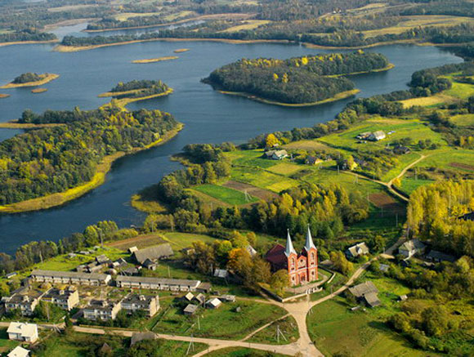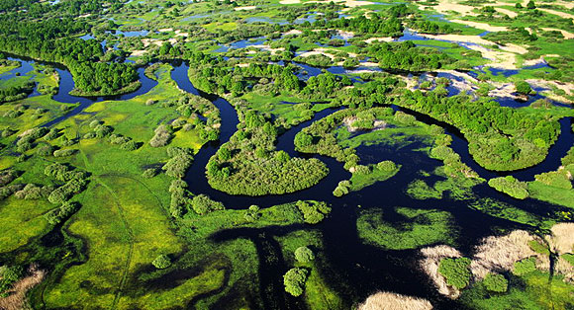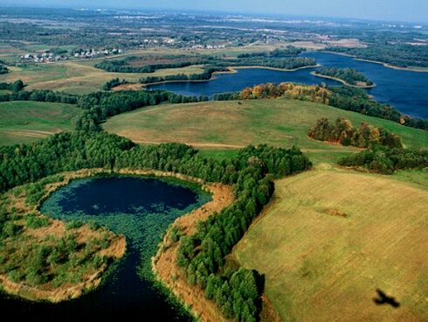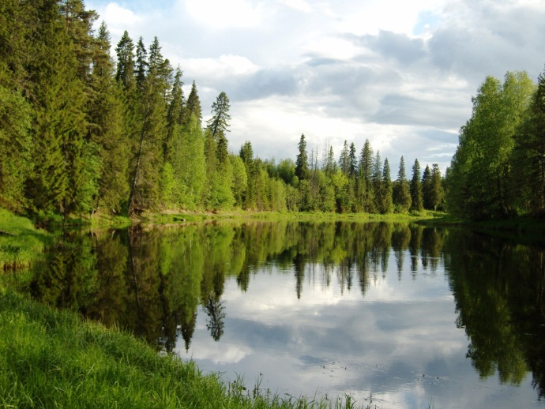

**Beresinski biosphere reserve**

**Established for the protection and breeding of rare animal species that are listed in the national Red Book (originally created for the protection of beavers) and birds. Included in the world network of biosphere reserves of UNESCO.**

**Due to its biological diversity and unique natural complexes the reserve has exceptional importance not only for Belarus, but for Europe as a whole.**

***Department of Tourism* +375 21 322-63-18**

[**www.berezinsky.by**](http://www.berezinsky.by)**, tourism@berezinsky.by**

**Pripyatsky National Park**

**Polesie of the Pripyat is situated in the south of Belarus in the center of a vast plain. Polesie is one of the most interesting geographical areas in Belarus. It spreads out on both sides of the Pripyat River in its middle course. This area is defined by high wetlands, poorly developed area and good preservation of natural complexes.**

**+375 2350 5-70-02**

**www.npp.by/en/,** [**lyaskovichi@npp.by**](http://www.npp.by/en/)

**Narochansky National Park**

**Narochansky National Park is the land of unique nature and positive energy. Lake Narach – the largest lake in Belarus – is the gem of the Narochansky region. The resort area is located on the lakeside.**

**Lenin Str., 11, 222395, r.v. Narach**

**Myadel district, Minsk region, Belarus**

**+3751797 49807 Department of Tourism**

[**www.narochpark.by**](http://www.narochpark.byб)**,** [**info@narochpark.by**](mailto:info@narochpark.by)

**The Braslav Lakes National Park**

**The Braslav Lakes National Park is a unique place. It is the place for passive and active recreation, tourism, fishing and hunting. A number of lakes and pine forest maintain the air amazingly pure. The pine forest is within the Braslav city limits. Its northern part drowns in the pine forest and is located on the lake shore.**

***Department of Tourism* +375296638774**

***On hunting tours* +375291104407**

**www.braslav.com,** [**braslav\_by@tut.by**](mailto:braslav_by@tut.by)

**Nature of Belarus**